How to take Debug level logs for HySecure Client

- Go to Registry Editor in user's machine.
  - Open RUN(Win+R).
  - Type “regedit” and enter.

- Go to below location and change log level to 7.
  - Go to this location HKEY_LOCAL_MACHINE > SOFTWARE > Accops > HySecureClient
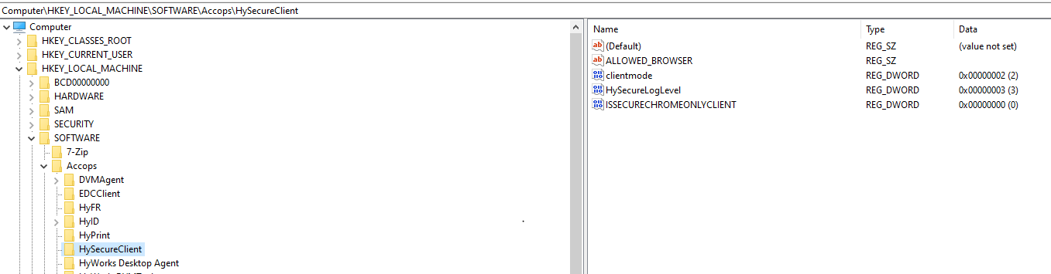

  - Double click on “HySecureLogLevel”
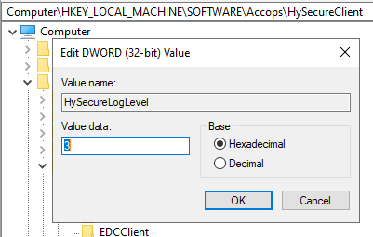

  - Replace “3” with “7”
- Then relaunch the client, login and launch application.
- Now, go to right side of “Task Manager” and click on
- Right Click on HySecure icon and click on View Logs.
- “uaclogs” will open. Collect them and share with us
- If you can’t find option for View Logs.
- Please open RUN(Win_R)
- Type “%temp%”
- Search for “uaclogs“
- Collect them and share with us.
NOTE: Please revert the HySecureLogLevel value to 3 once the logs are collected.

