Replace KIOSK mode with Windows Group Policy and Registry settings for Full screen

ISSUE with Kiosk Mode : An additional window opens when user click on a link from web application published from HyLite, if that window is minimized we are unable to Maximize.

We have checked and found one option in which Kiosk mode will be disabled and changes will be done in group policies and Registry. Below are the changes that we have to make :
1. In Group Policy:
-- Go to Computer Configuration > Administrative Template > Windows components > Internet Explorer > Enforce Full Screen--> Enable it as shown below:

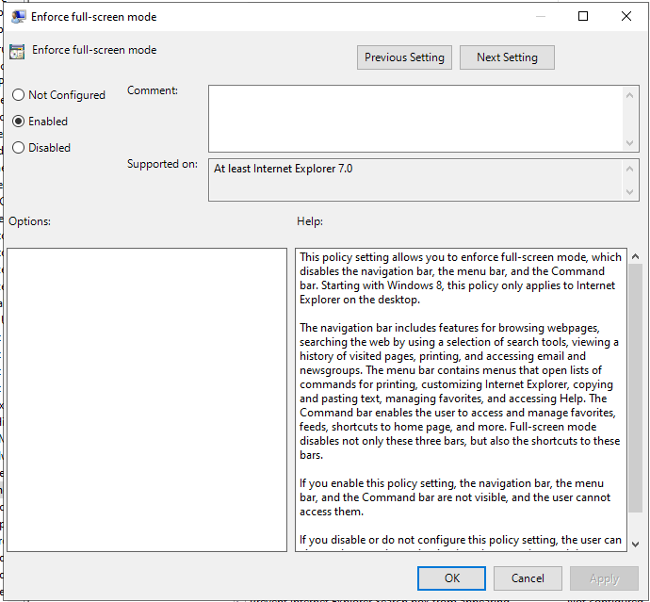

2. In Registry Editor:
-- Go to Computer\HKEY_LOCAL_MACHINE\SOFTWARE\Policies\Microsoft\Internet Explorer\Toolbars\Restrictions. Make changes as shown below:
> NoCommandBar as 0.
> NoNavBar as 0.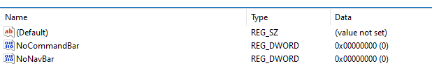

After these changes, Web browser will look like KIOSK mode and can be minimised as well. URL will be editable but website access can be restricted from the proxy server and user won't be having access to internal drives due to group policy settings.
Limitation : Developer tools may work(need to be checked)

