Apply Folder redirection policy and Roaming profile on RDS servers.

- Login into Active Directory server and open Active Directory Users and Computers.
- Create one OU (eg., Propalms OU)and RDS servers into that OU.
- Open GMPC.msc and create one GPO and linked it to new created OU.
- Right click on new created GPO and edit and apply below policy as shown in image.
Computer configuration->Administrative Templates->System->Group Policy
Set Policy “Configure user Group Policy loopback processing mode” to enabled and mode: Replace

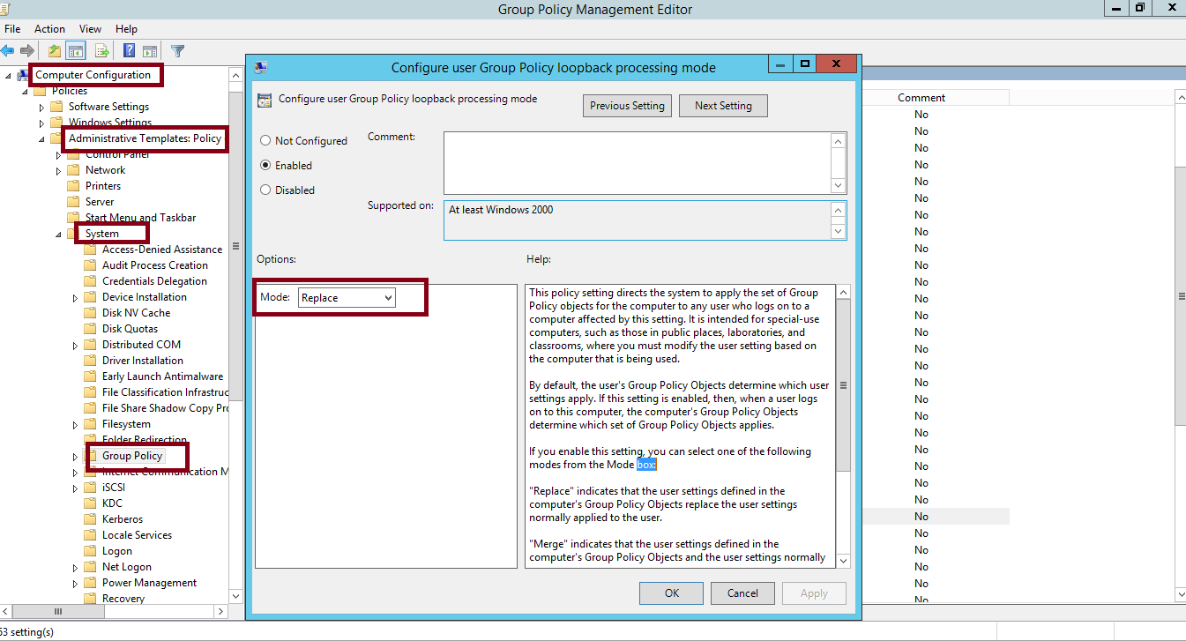

- Now go to User configuration->Windows Settings-> Folder Redirection
Right click Desktop and click on properties and do changes given in image.
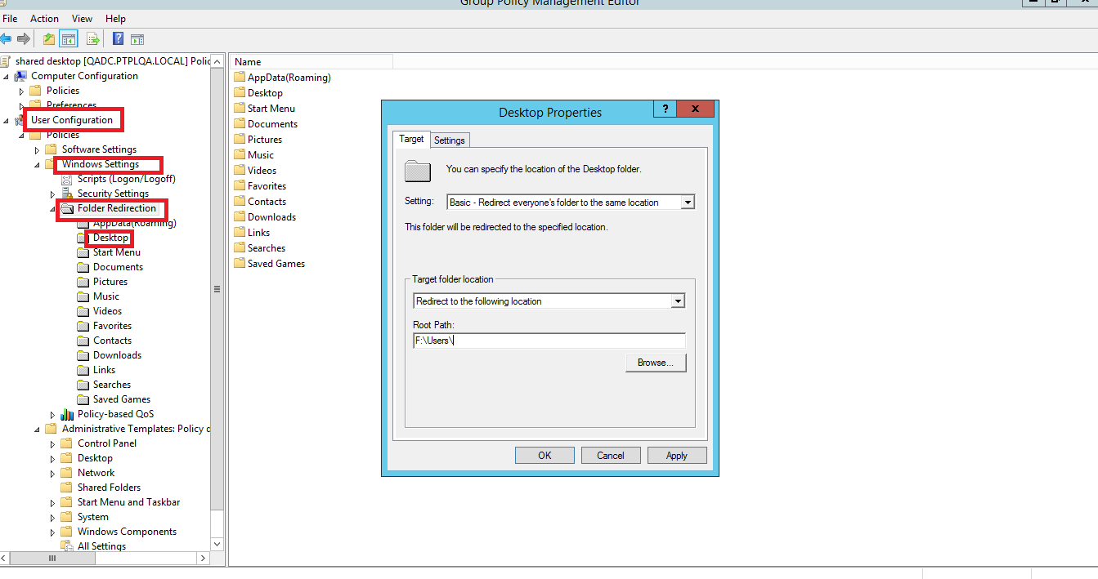

- Follow steps 5 for Appdata (Roaming),Documents, Downloads,Music,Videos folder redirection.

- Apply Roaming profile to be created if logged in on RDS servers.
Computer configurationAdministrative templatesSystem User Profile.
Select : Set Roaming profile path for all users logging into this computer
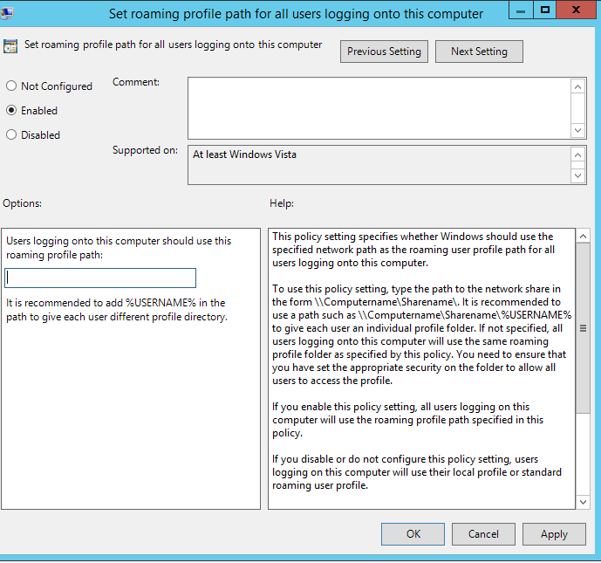
- Now to apply group policy to terminal server and specific users ,add the computers and users in security filtering of that GPO.

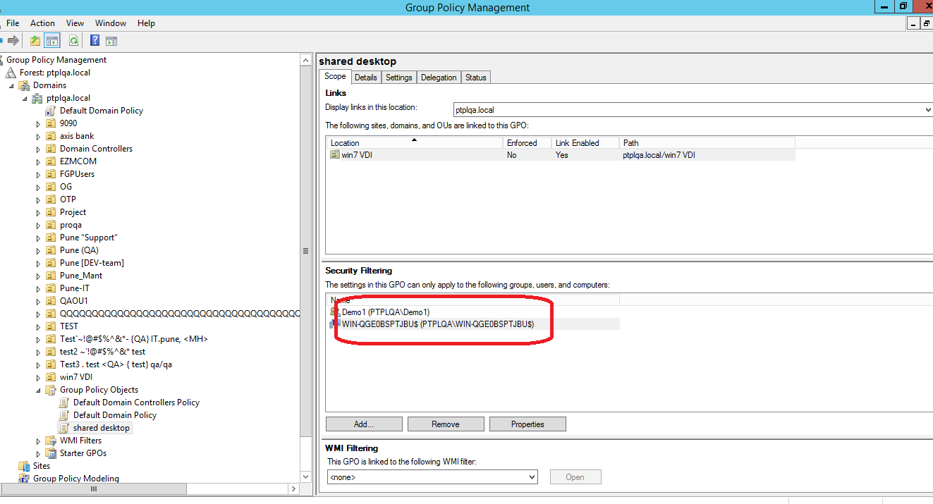

9)Open Run-type gpupdate /force and click on OK

