How to resolve MSTSC License creation stored failed issue

Issue: When user launch any application, Application, SHD not launch and not given any message. If you try to take plane RDP, then it shows below error license issue

Error: The remote session was disconnected because license store creation failed with access denied.
Please run remote desktop client with elevated privileges. (This error show only when you take rdp of session server)
Snapshot:
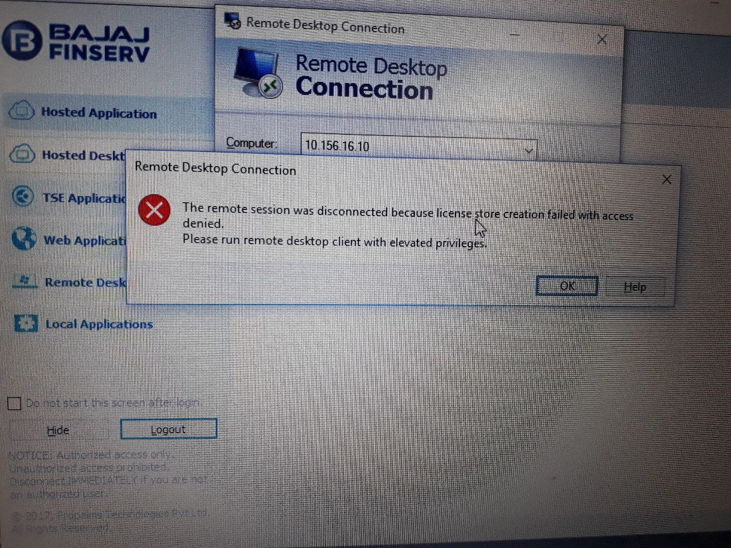

Solution:
1.Launch Accops Hysecure Client and login with your AD ID
2.Open C:\windows\system32 and right click on mstsc.exe file
Select Run as Administrator, (refer below snapshot)
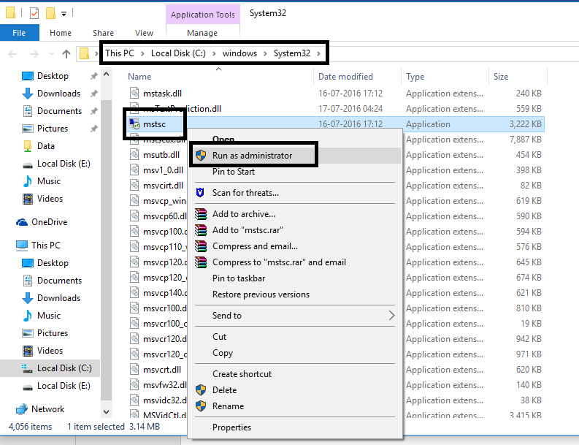
3.In remote desktop connection type session server IP(10.156.16.9 or 10.156.16.10) and login in server with your AD username, Password (it required only first time).
4.Now you can launch Application from Hysecure client, now Applications launch automatically without any error.
5.If still issue occur then Run Accops RDS CAL tool on user system with admin rights. Please download Accops RDS CAL tool by using below link.

http://support.accops.com/solution/articles/12000025869-troubleshooting-tse-application-launch-fails-with-terminal-services-client-access-license-error
5.After running this tool reboot user system
6.If still issue occur, give full rights from Security to mstsc.exe and mstscax.dll file from C:\windows\system32 for current user then try to take plan RDP and try to launch application.

For any assistance: kindly write to support@accops.com

