Hyworks Controller Microphone Settings

- Please login controller and check which profiles is assigned to user facing issue.

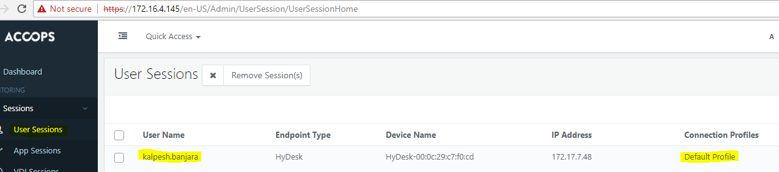

- Go to that Workspace connection profile
- Select the profile edit

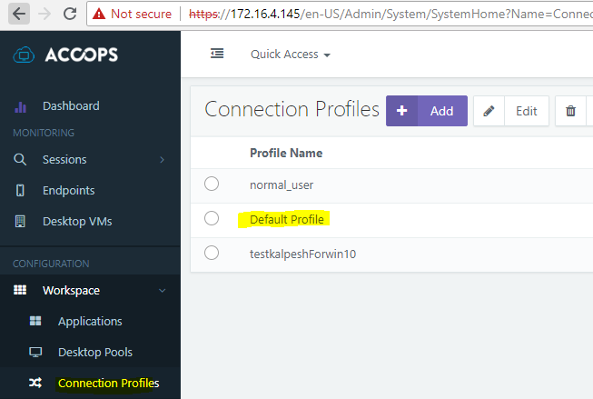

- Under edit goto resources tab as shown and check if Microphone settings are checked.

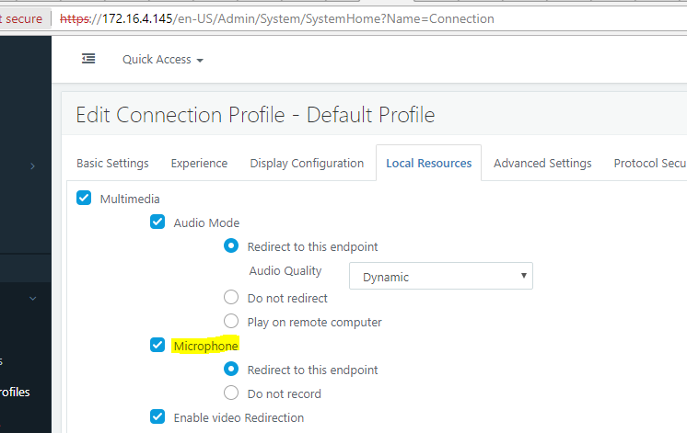

Now Signout from hyworks client and sign in again .
New settings should be applied and microphone should redirect .

Note: If you do not want all/ few users to have this settings then you need to create a separate profile for those users facing issue and configure the above shown profile for them.
You can then assign the profile based on Endpoints, Desktop pool or directly to user from Entitlements.

