How to Resolve SAS Enterprise Guide needs to close (SAS Not Launching) issue in SHD for particular user
Purpose:
How to Resolve SAS Application was not Launching issue for particular user in SHD where other users able to access SAS application from same RDS server and application is working fine on Application server.
Issue:
The particular user was unable to access SAS enterprise Guide application in SHD.After launching SAS application it was close automatically. Other users from same application server able to access SAS application and SAS application is working properly on same Application server. This is user specific issue.
Snapshot:
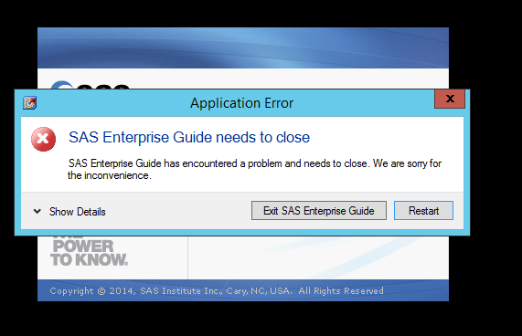

Issue Detail:
When particular user launch SAS application in SHD then user get above error and not able to access Application however other users able to access same application from same server. This issue occurs when user SAS profile files was corrupted which is created in user appdata\roaming\sas\Enterprise Guide folder path at the time of SAS profile creation.SAS profile created after launching SAS application.

Solution:
1.Take remote of Application server or take remote user where user access SHD of application server
2.Open appdata folder of same user in Application server.
3.Open mention path C:\users\username\appdata\roaming\SAS
4.Rename EnterpriseGuide folder to EnterpriseGuide1.When user launch SAS application SAS user profile will by default created with EnterpriseGuide name in same location and user able to launch SAS application in same RDS server.(Refer snapshot)
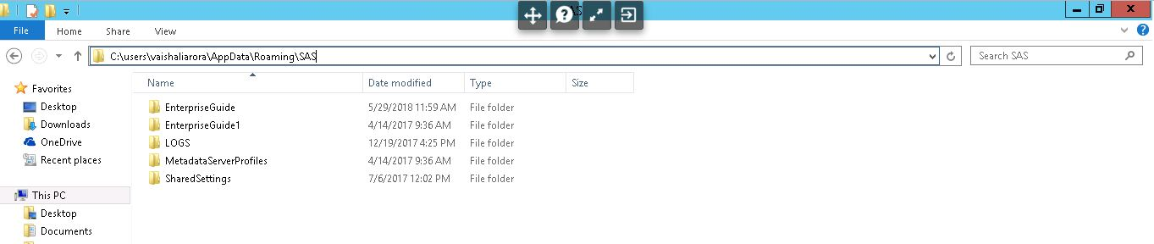
5.Now user able to access SAS application in SHD.

