Error message when you open SQL Server Configuration Manager in SQL Server: "Cannot connect to WMI provider. You do not have permission or the server is unreachable"

Symptoms

On a 64-bit computer, you install an instance of the 32-bit (x86-based) version of Microsoft SQL Server. On the same computer, you install an instance of the 64-bit version of SQL Server 2008. If you then uninstall the 64-bit instance, you receive the following error message when you open SQL Server Configuration Manager:
Cannot connect to WMI provider. You do not have permission or the server is unreachable. Note that you can only manage SQL Server 2005 and later servers with SQL Server Configuration Manager.
Invalid namespace [0x8004100e]
This problem also occurs if you uninstall the 32-bit instance, and you then open SQL Server Configuration Manager.

Snapshot

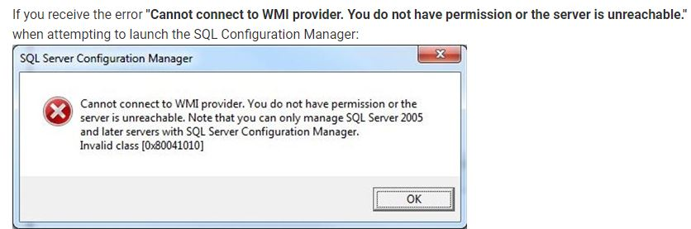

Cause

This problem occurs because the WMI provider is removed when you uninstall an instance of SQL Server. The 32-bit instance and the 64-bit instance of SQL Server share the same WMI configuration file. This file is located in the %programfiles(x86)% folder.

Workaround

To work around this problem, open a command prompt, type the following command, and then press ENTER:
mofcomp "%programfiles(x86)%\Microsoft SQL Server\number\Shared\sqlmgmproviderxpsp2up.mof"
Note For this command to succeed, the Sqlmgmproviderxpsp2up.mof file must be present in the %programfiles(x86)%\Microsoft SQL Server\number\Shared folder.
The value of number depends on the version of SQL Server:nnn
For Microsoft SQL server 2012 used below command:
mofcomp "%programfiles(x86)%\Microsoft SQL Server\110\Shared\sqlmgmproviderxpsp2up.mof"
Microsoft SQL Server 2012 | 110
Microsoft SQL Server 2008 R2 | 100
Microsoft SQL Server 2008 | 100
Microsoft SQL Server 2005 | 90
After you run the Mofcomp tool, restart the WMI service for the changes to take effect. The service name is Windows management Instrumentation.

