How to enable csv export option to generate reports in csv format in TSE

1.Take RDP of TSE server
2.Open IIS manager (Start—IIS manager)
3.Expand IIS manager (refer below snapshot)
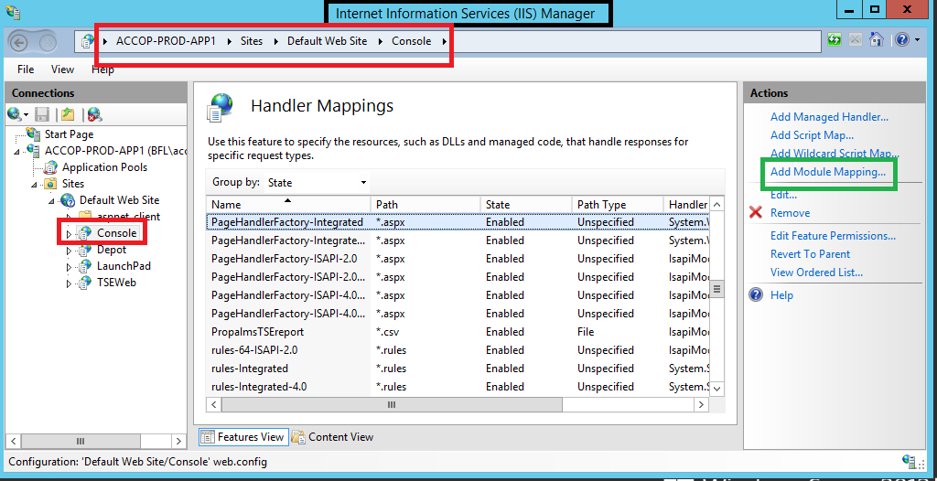
4.Click on Add module mapping and Fill field in box (Refer below snapshot)
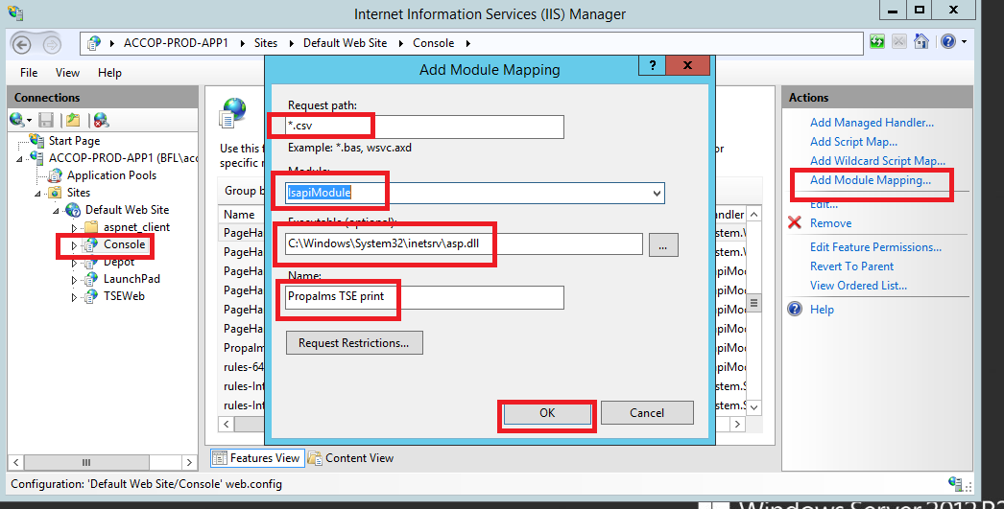
6.click on OK. Now try export file in csv format from TSE management console

